INSTITUTO TECNOLÓGICO DE ESTUDIOS SUPERIORES DE OCCIDENTE
Departamento de Electrónica, Sistemas e Informática.


Practice 5 - Integrate a cloudflare app

INFRAESTUCTURA PARA EL DESARROLLO CONTINUO
Héctor Alfonso Sandoval Bautista
737119
18/09/2026
Nombre del profesor: LUIS EDUARDO ESTRADA RODRIGUEZ

1.Create a Public or private repo in GitHub
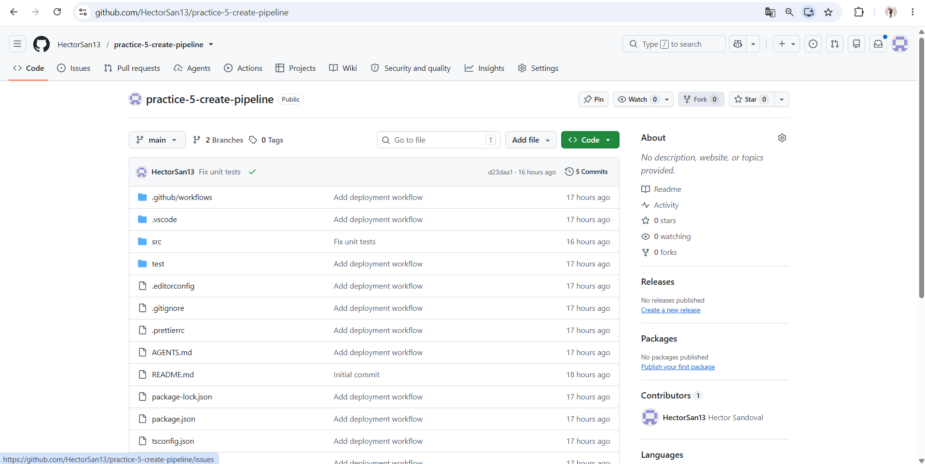

2.Clone the new repo
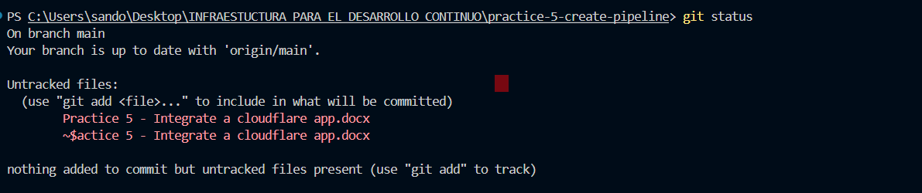

3.Create a new project using cloudflare cli

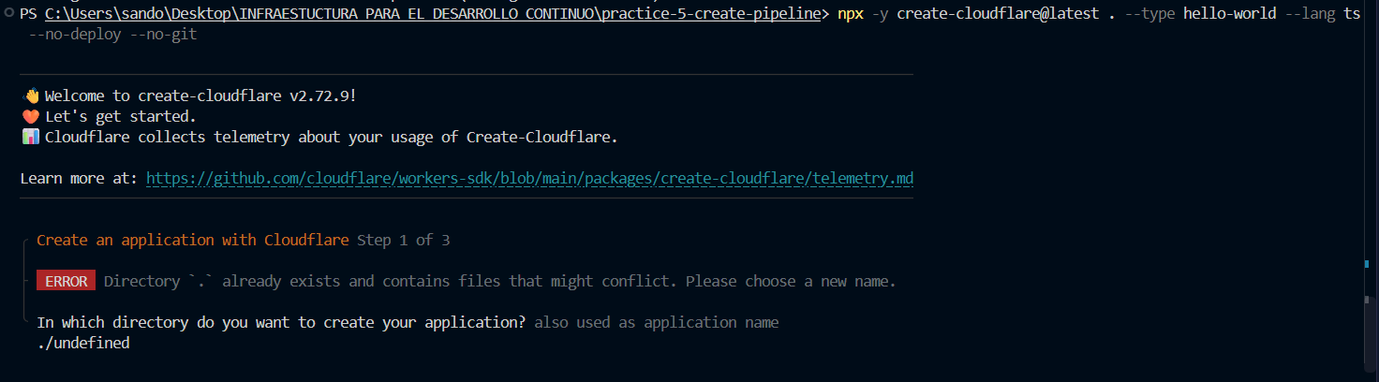

4.Create a cloudflare account
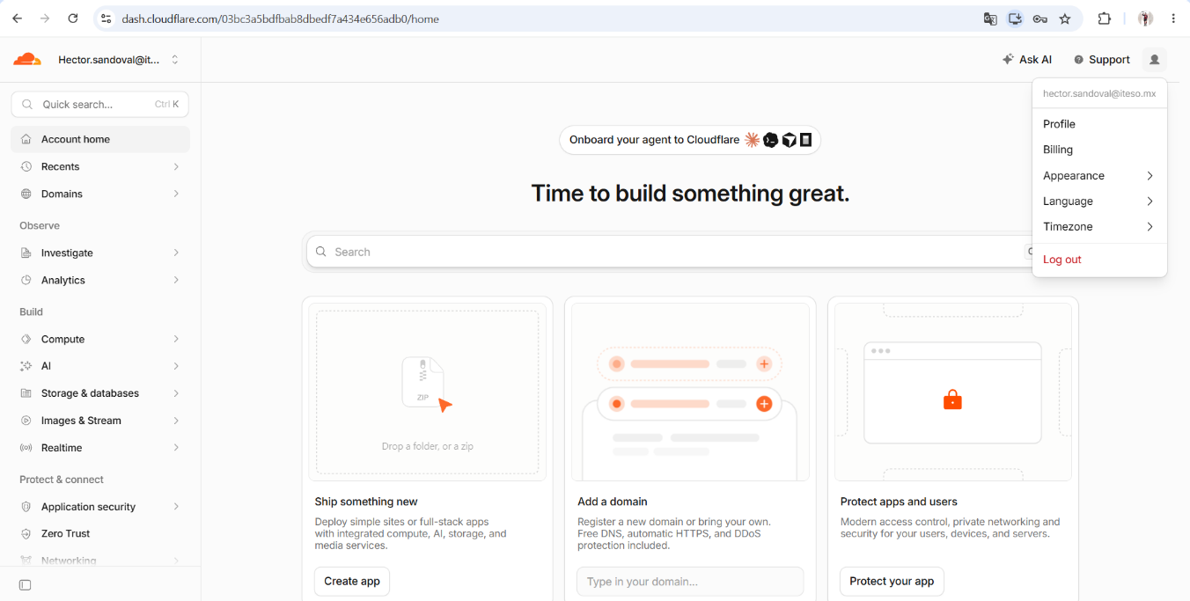

5.In the Build/Compute options go to workers and Pages
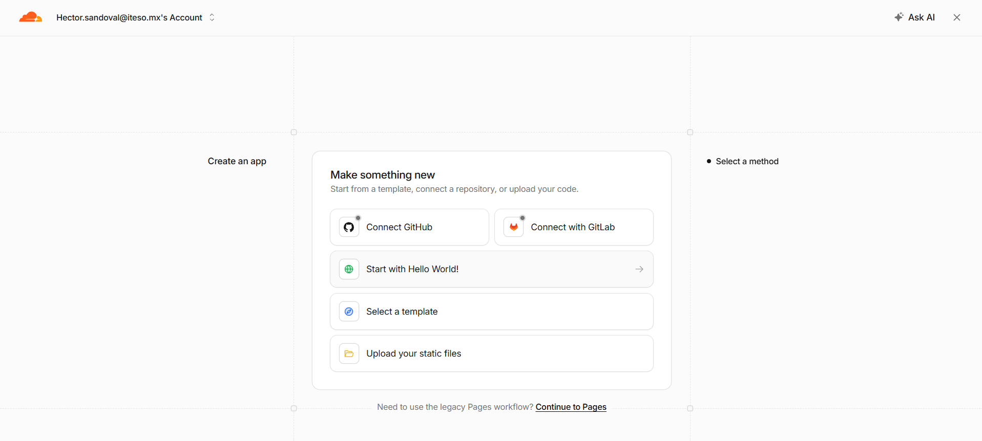

6.Create a new application

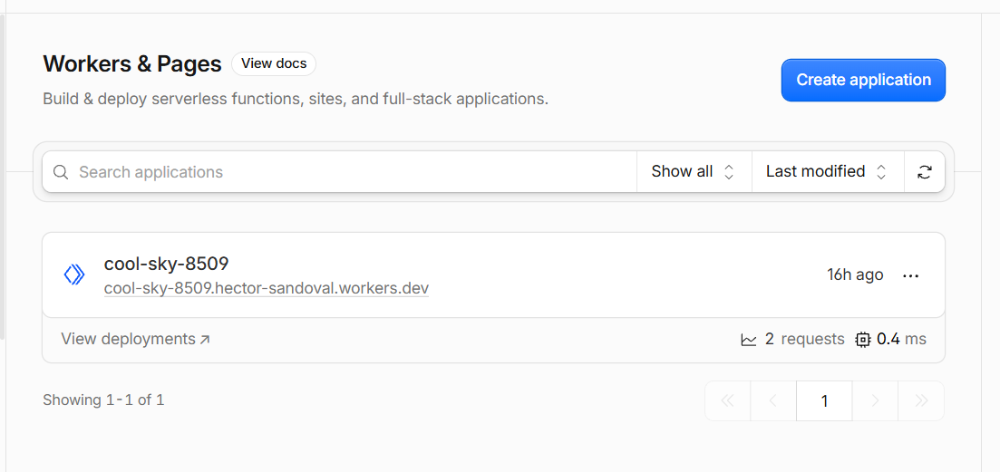

7.Link with GitHub al select the new repo

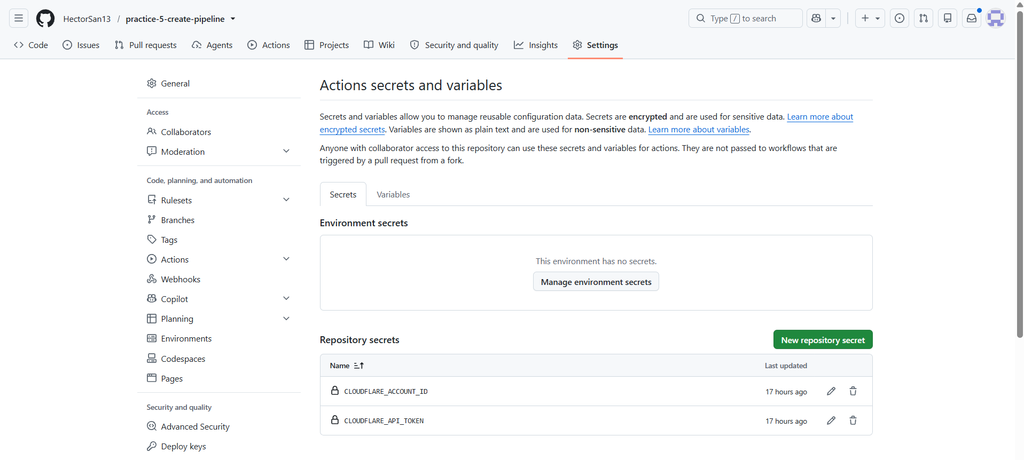

8.Deploy the application
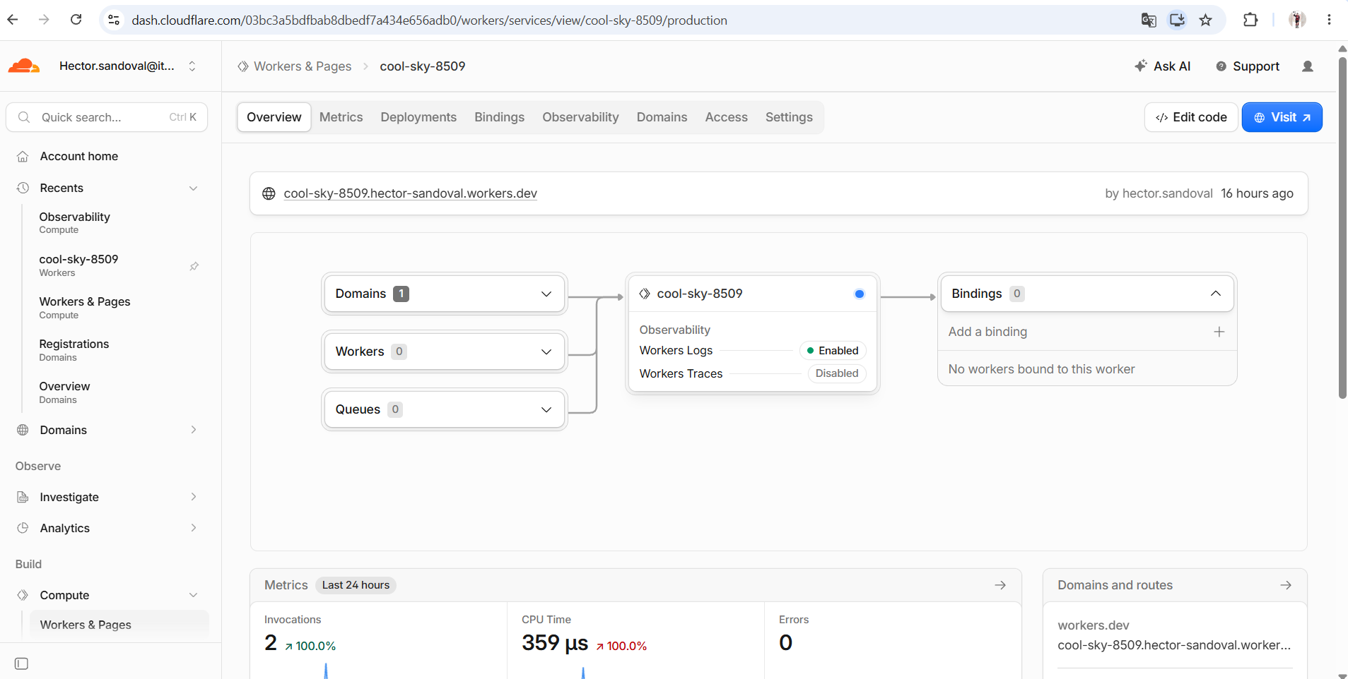

9.Chek the cloudflare logs and visit the application

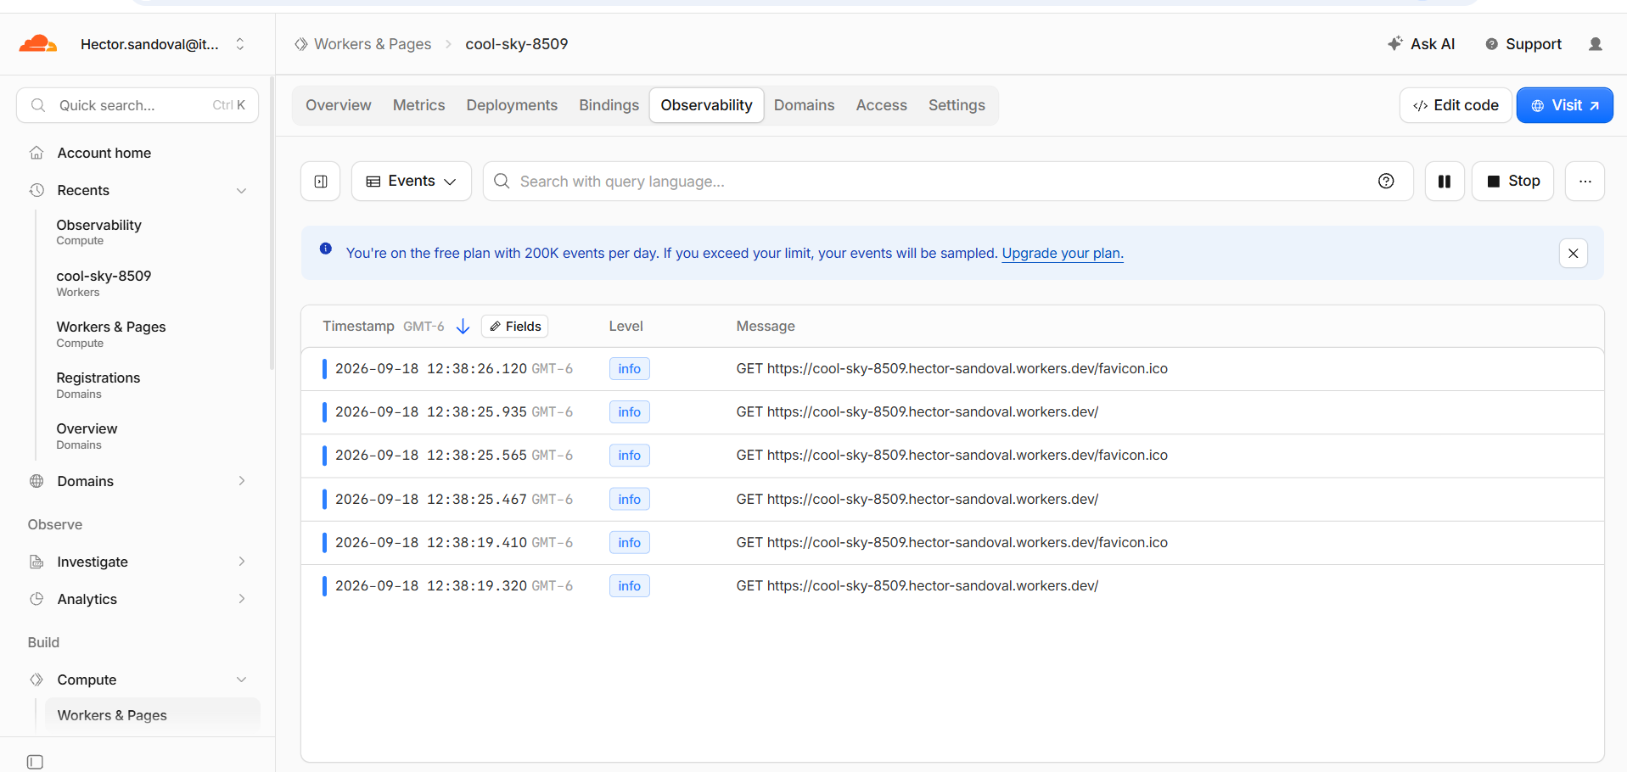

10.Using IA modify the new project and push to GitHub

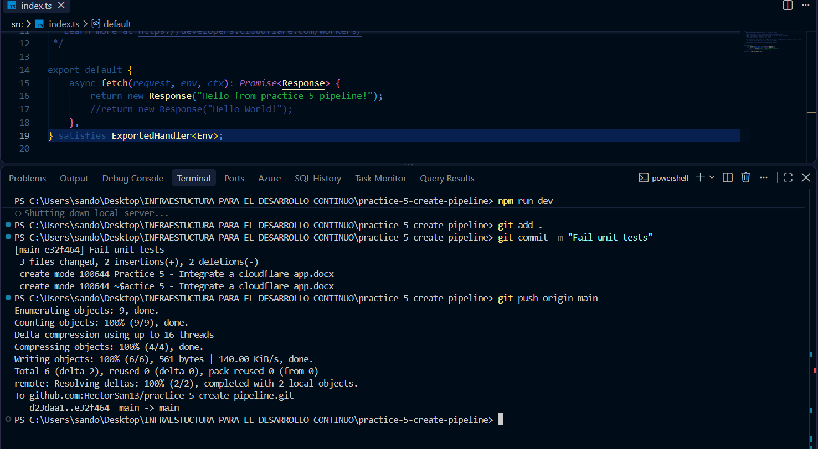

11.Check the changes
